**Game Name:** Escape from Fall Guys

**Genre:**

3D platformer

**Game Platform:**

PC

**Target Audience:**

5+, Childish art style and challenge lovers.

**Game Overview:**

The astronaut named Boris, got was kidnapped from Among Us and brought to Fall guys as fall guys, guys got angry that among us stole their spotlight. He finally escaped the pedestal prison and now has to navigate though the level to reach a communication tower where he will be able to call his friends for from using his tablet.

Boris has to navigate through the level while not hitting any obstacle or falling in any ravine/hole. If the player trips or falls, his laptop is going to drop, breaking it slowly. If the tablet drops more than a certain amount of times, the table will break completely, and you lose the game.

**Game Objective:**

Reach the end of the levels while holding your intact tablet.

**Game Layout and Design:**

**Core Aesthetics:**

* Challenge: Finish the game without breaking your tablet
* Fantasy: Play as Boris!
* Submission: Play in your own time.

**Core Game Play:**

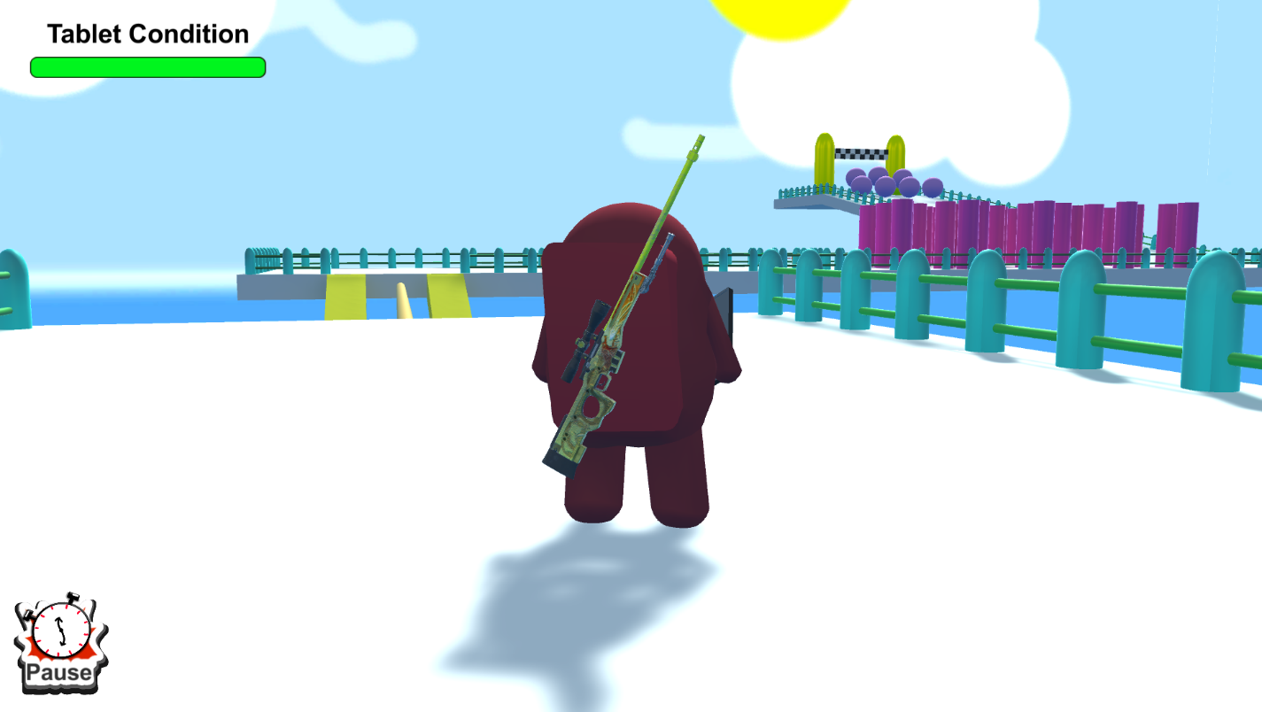

* Platform: Player moves and jumps around in a level trying to reach the goal.

**Rules:**

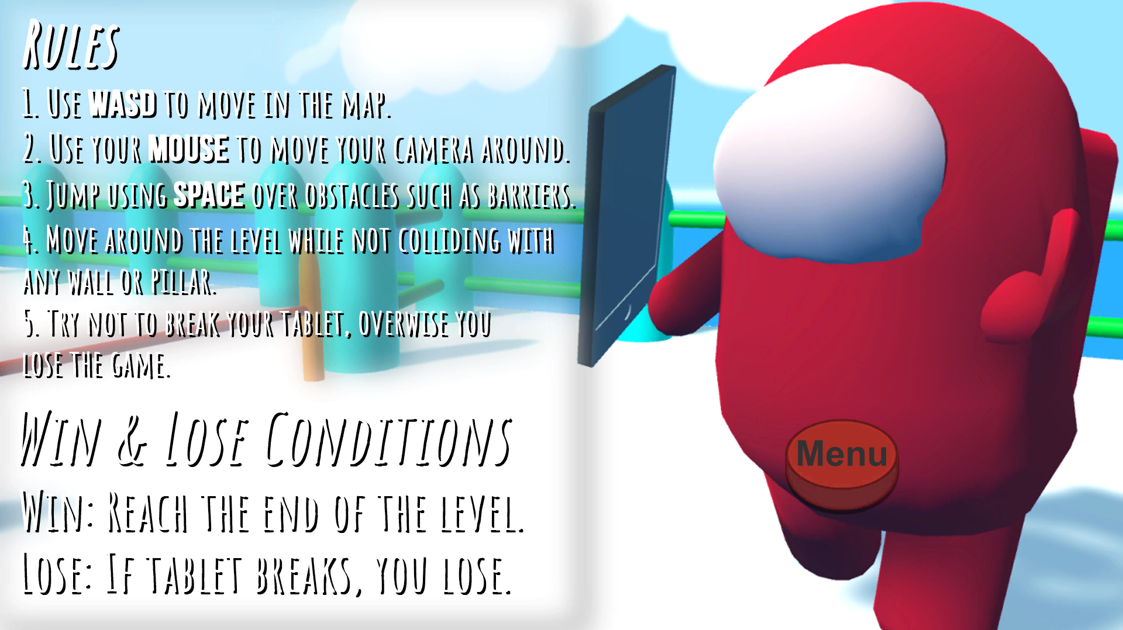

* Use WASD to move in the map.
* Use your mouse to move your camera around.
* Jump using SPACE over obstacles such as barriers.
* Press E to pick up tabler.
* Move around the level while not colliding with any wall or pillar.
* Try not to break your tablet, overwise you lose the game.

**Core Loop:**

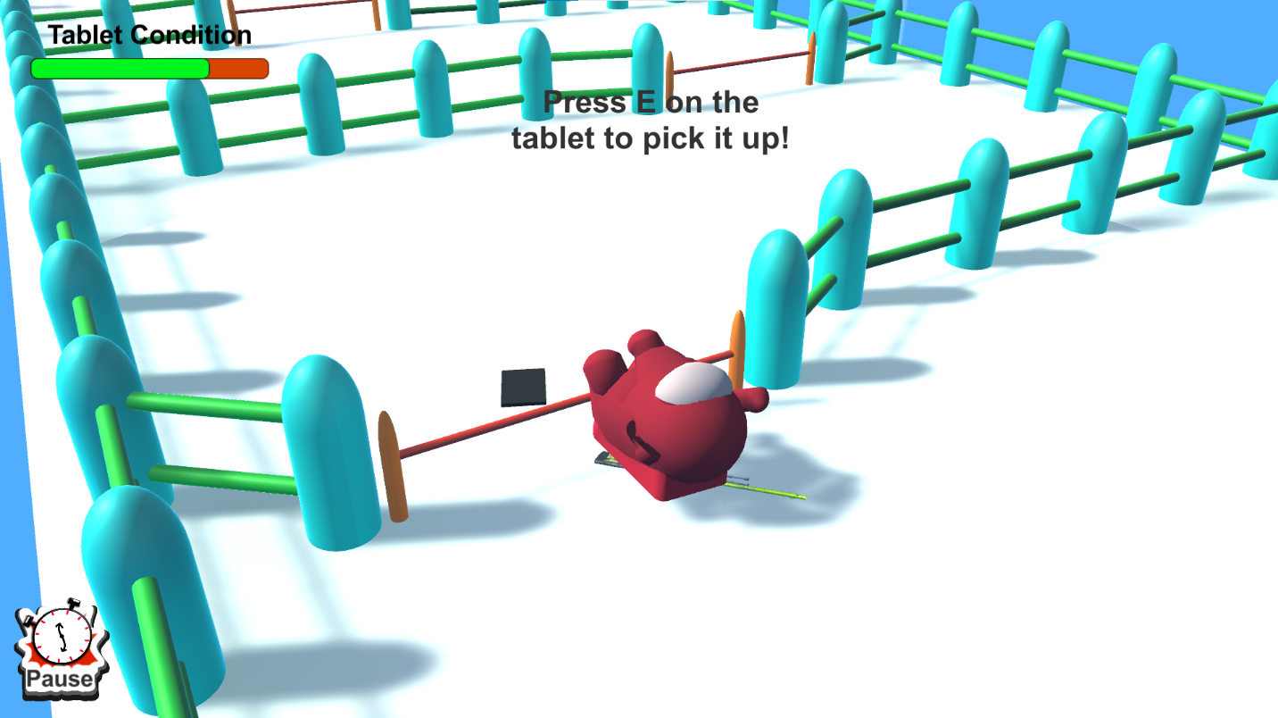

* Action: Move around obstacles -> trip -> grab tablet -> reach end -> repeat
* Reward: Enter the next level or get in the spaceship.

**Win and Lose Condition:**

* Win: Reaches the end of the level.
* Lose: If tablet brakes, you lose.

**User Interface:**

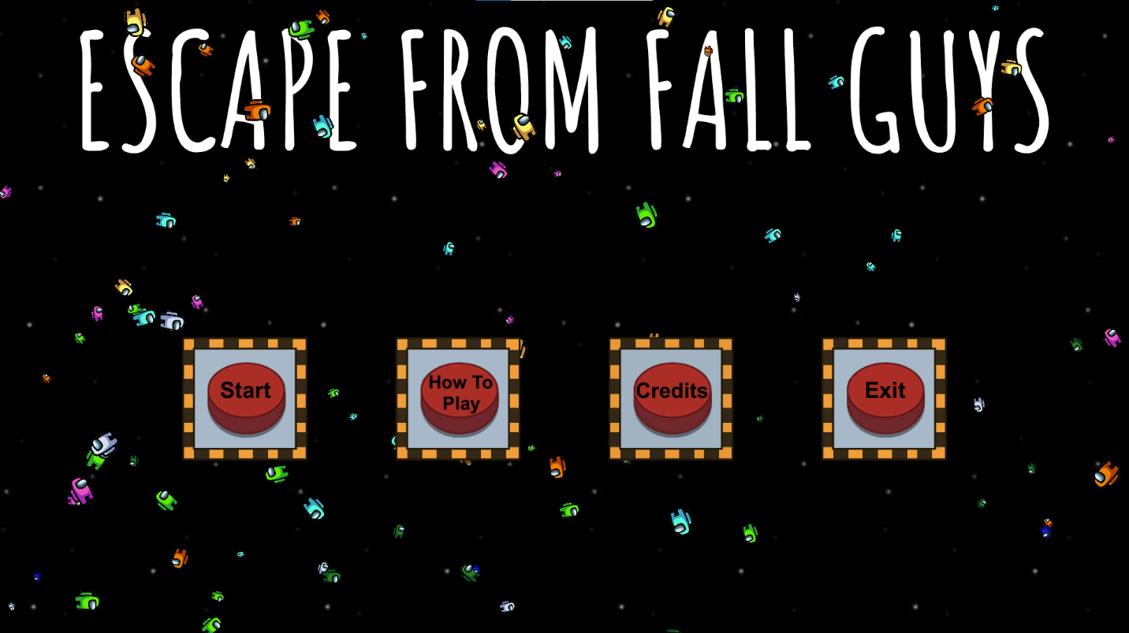

* Start – You will enter the world of fall guys!
* How to Play – Controls.
* Credits – Contributors of the project.
* Exit – Quit the game.

**Unique Selling Point:**

* Play among us and fall guys in the same game.
* Funny animations
* Extreme dexterity needed to complete the level. Only for extreme gamers!

**Comparative Analysis:**

Among Us & Fall Guys:

* Pros: You can play repeatedly without having to wait for your friends to die.
* Cons: It is not a multiplayer

**Feature (Mechanics):**

Player: Move left, right, forward, backwards, jump

Obstacles: Touch and trip and tablet gets damaged

Holes: Fall and tablet get damaged

**Credits:**

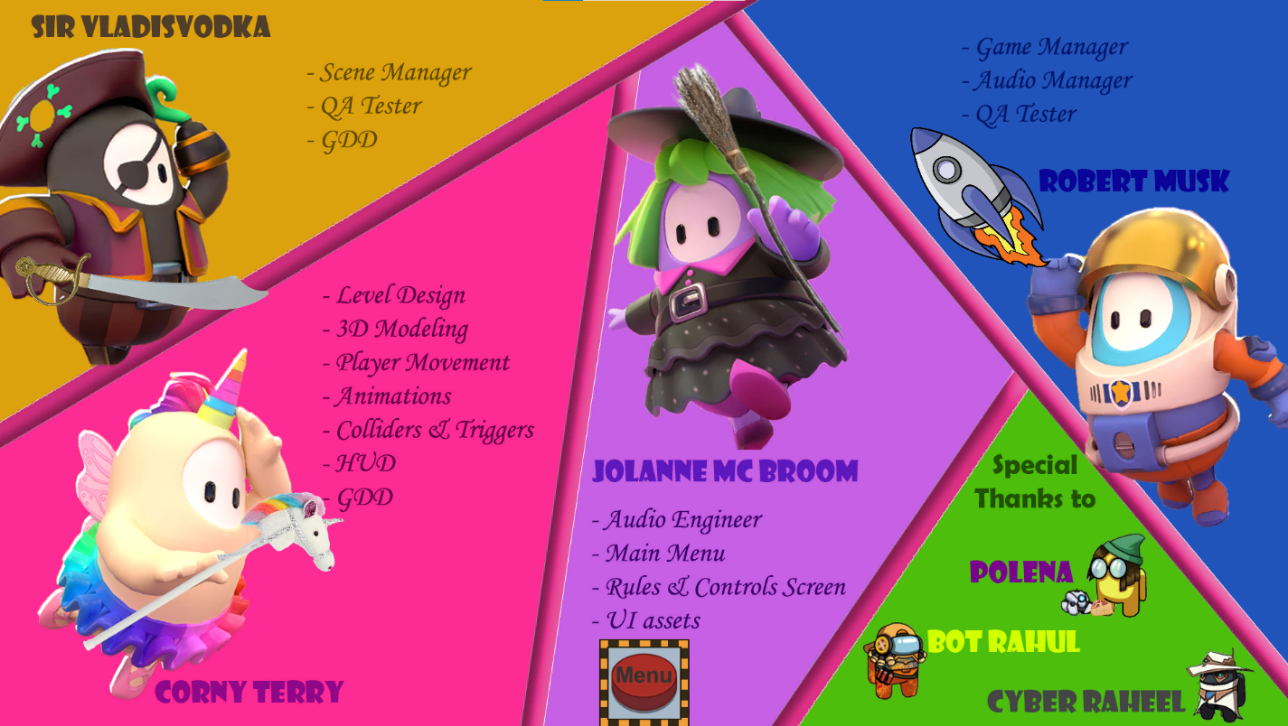

* Terry – Lead Programmer, Animator, 3D Modeller
* Jolanne – Lead Artist, Audio Engineer
* Robert – Programmer (Game Manager, Audio Manager)
* Vladislav – Programmer (Scene Manager, Documentation)